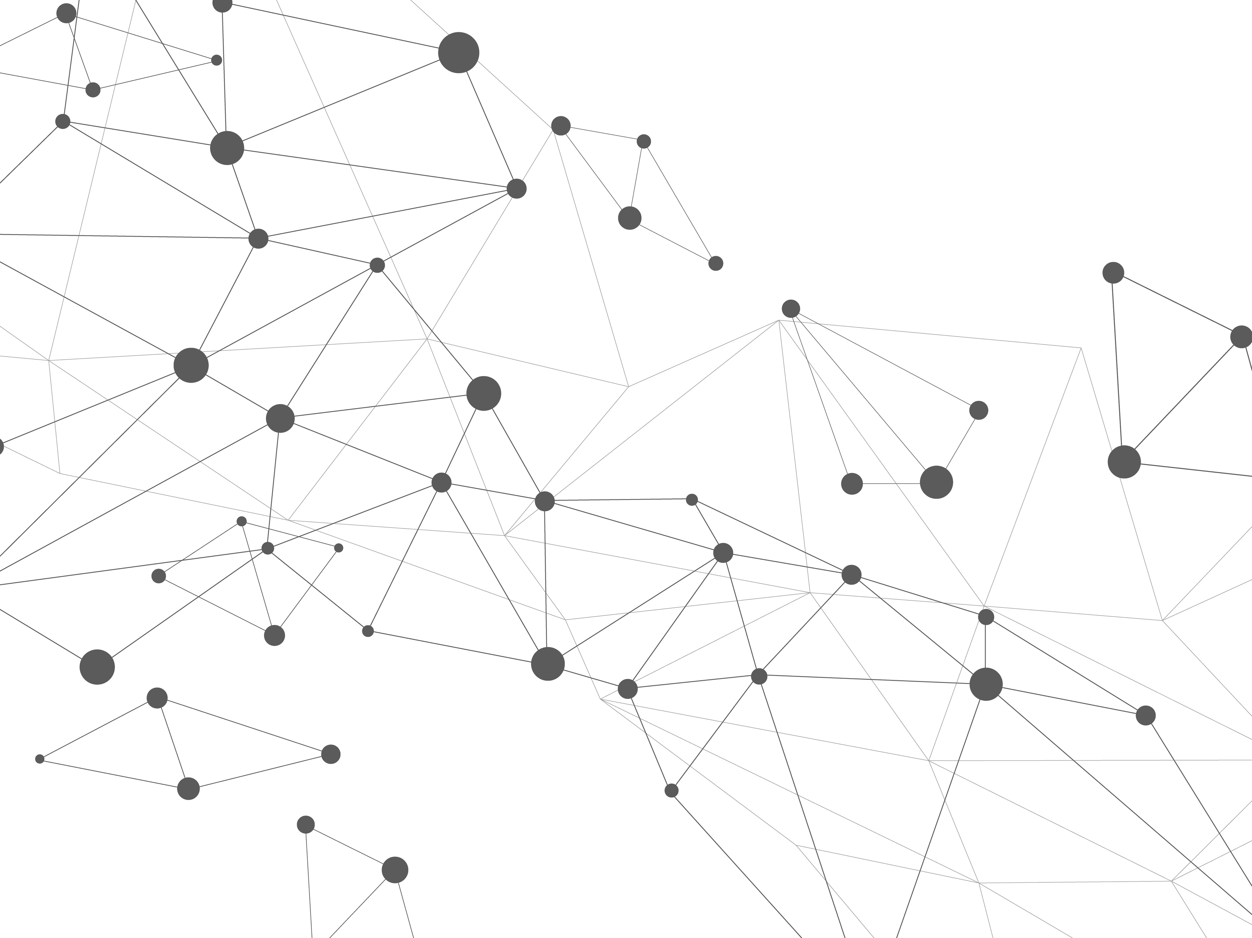
#forschungstwittern

Emerging Researchers (@HistEdGER)
Division 1 – History of Education
German Educational Research Association (GERA/DGfE)

We are happy about your interest in contributing to our Twitter series #forschungstwittern!

Please send us your completed template by email to:
hbf.forschungstwittern@uni-muenster.de

First, we need some information about you and your project:

Name:
Twitter account:
Institutional affiliation:
Twitter account of your institution, if available:
Title of your research project:

A tweet consists of a maximum of 280 characters including spaces. Several tweets make a thread. As you can see from our call for tweets, every second Monday a (dissertation) project should be presented in 6 to 10 tweets (= one thread), i.e. in 1,680 to a maximum of 2,800 characters.

Please consider the following points:
- Each tweet must be numbered at the end (1/6, 2/6, 3/6, … 6/6).
- Important terms can be highlighted with a #hashtag, but no more than one or two per tweet.
- Abbreviations and special characters (e. g. „&“ for „and“) can be used to save characters. Please use them consistently and check the readability of your tweets afterwards.

You can submit your thread by using this template:

tweet #1
tweet #2
tweet #3
tweet #4
tweet #5
tweet #6
tweet #7
tweet #8
tweet #9
tweet #10

We are looking forward to your submissions!

Lilli Riettiens & Andreas Oberdorf

